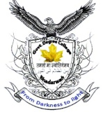**OFFICE OF THE PRINCIPAL**

**GOVT. DEGREE (PG) COLLEGE BHADERWAH (J&K)**

**(NAAC Accredited ‘B’ Grade Cycle-2)**

**E-mail : [principalgdcbhaderwah@gmail.com](mailto:principalgdcbhaderwah@gmail.com), Ph/Fax:01997244155/+919419910916, website: www.gdcbhaderwah.ac.in**

**\*\*\*\*\***

**Press Release**

**Govt. Degree (PG) College Bhaderwah organized a seminar on Cyber Crimes against women and Impersonation Scam**

Under initiative of Govt. of India scheme Indian Cyber Crime Co-ordination Centre (14C) **Department of Computer Science GDC Bhaderwah** organized a seminar on Cyber Crimes against women and Impersonation Scam today on 28th March 2022 under the guidance of Dr. K K Sharma, Principal of the college. To start with the program Prof. Arjun Kotwal, HOD Computer Science Department and Nodal Officer Cyber Jagrookta Diwas presented the welcome address. On the occasion 12 student speakers namely Waseem Akram, Sonam Devi, Mohd Anis, Mukesh Kumar, Arsh Rathore, Diksha Manhas, Meenakshi, Abhilasha Kotwal, Payal Devi, Salooni, Arvind Sharma, and Vishal Bharti presented their papers on different issues related to Cyber Crimes against women and Impersonation Scam. The speakers through their powerpoint presentations drew the attention of the audience towards the day today crimes pertaining to Cyber Crimes against women. Among the faculty members Prof. Prithvi Raj and Prof. Ab Roof Batt presented their views on the occasion. Presenting his views during the program Dr. K.K. Sharma, Principal of the College motivated and guided the students and the staff to excel not only in academics but also in extra curricular and co- curricular activities. These activities become the part of quality initiatives of the college and the Teaching-Learning activity also gets enriched. The programme ended with a formal vote of thanks presented by Prof. Tariq Batt from Department of Computer Science. Large number of students and staff attended the programme. The proceedings of the programme were conducted by Miss Salooni from Computer Application Sem 2nd .

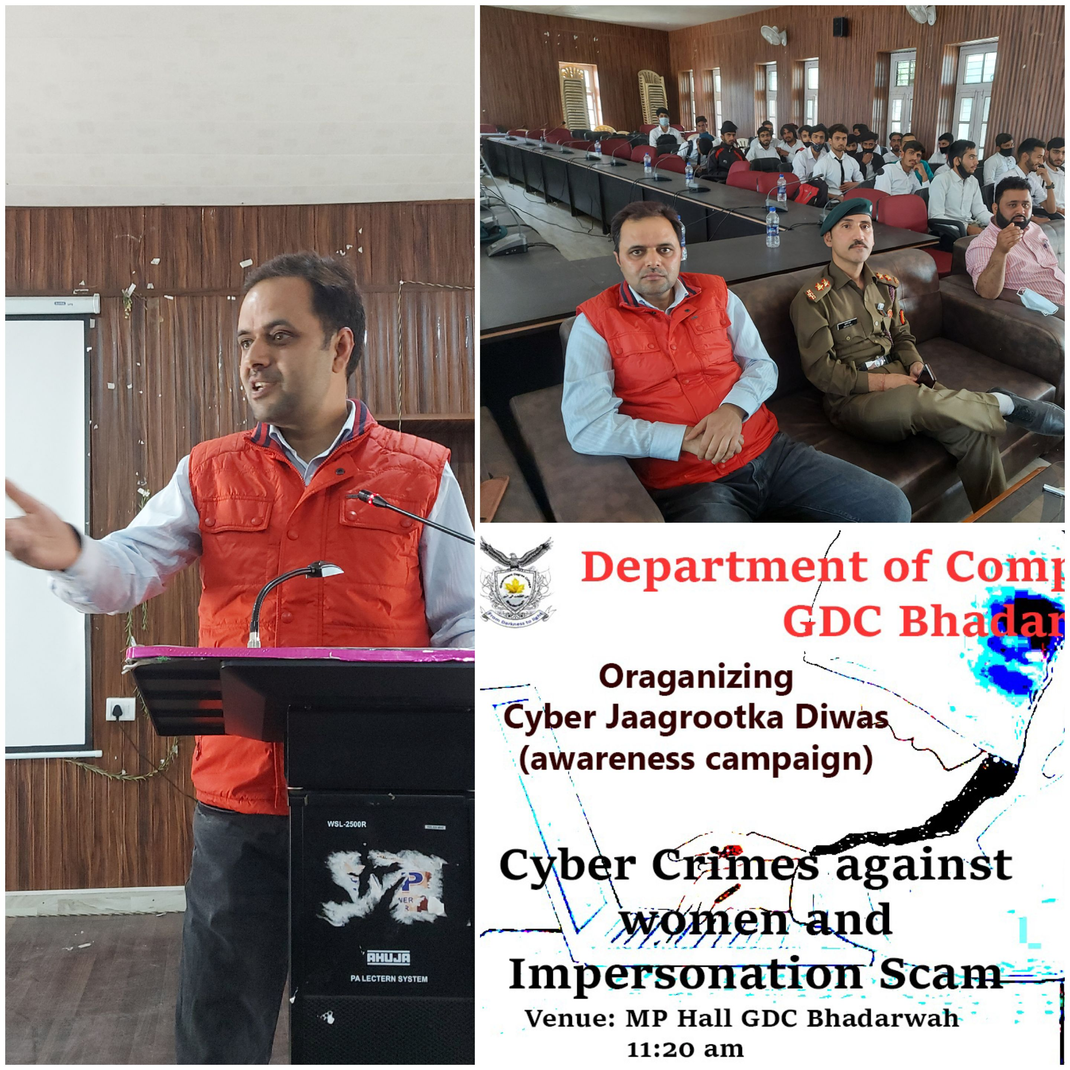

Principal

Govt. Degree College

Bhaderwah